Generate all binary strings
Problem Statement: Given an integer n, return all binary strings of length n that do not contain consecutive 1s. Return the result in lexicographically increasing order.
A binary string is a string consisting only of characters '0' and '1'.
Examples
Example 1:
Input: n = 3
Output: ["000", "001", "010", "100", "101"]
Explanation: All binary strings of length 3 that do not contain consecutive 1s.

Example 2:
Input: n = 2
Output: ["00", "01", "10"]
Explanation: All binary strings of length 2 that do not contain consecutive 1s.
Approach
- At each step, try to place '0' or '1' at the current position.
- You can always place '0'.
- You can place '1' only if the previous character was not '1'.
- Recurse until the length becomes n, and collect all valid strings.
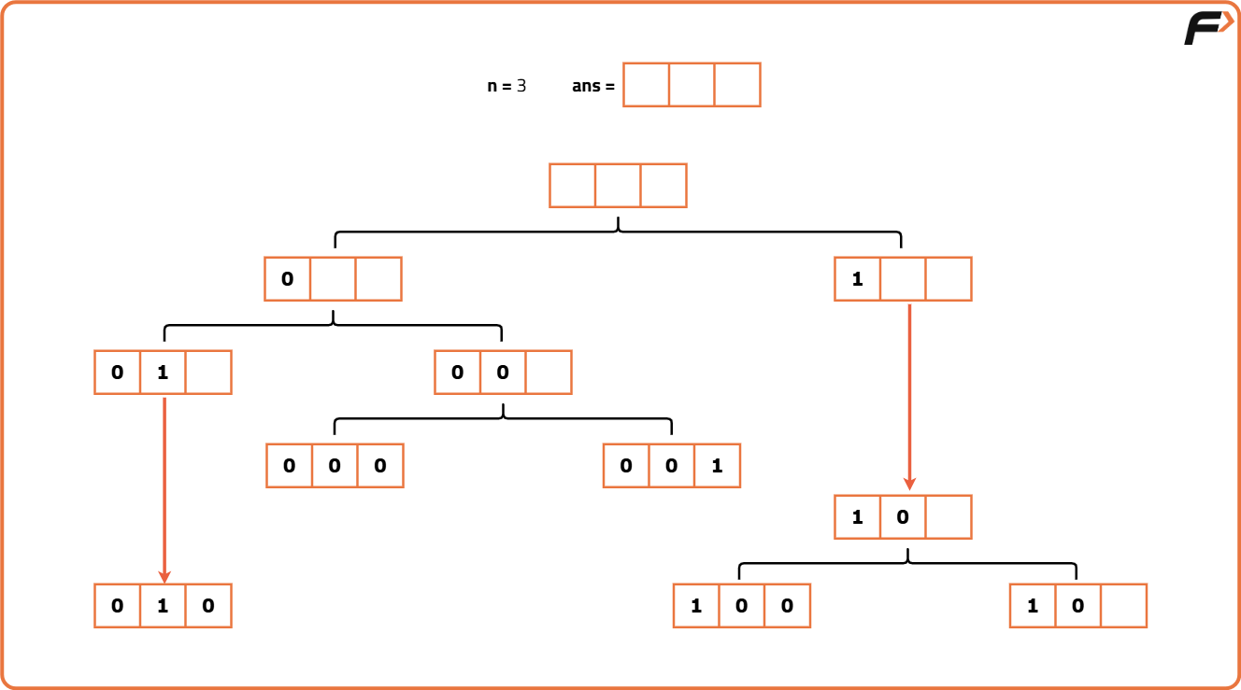

import java.util.*;
class Solution {
static void generate(int n, String curr, List<String> result) {
// Base case: if length is n, add to result
if (curr.length() == n) {
result.add(curr);
return;
}
// Always try adding '0'
generate(n, curr + "0", result);
// Add '1' only if previous char is not '1'
if (curr.isEmpty() || curr.charAt(curr.length() - 1) != '1') {
generate(n, curr + "1", result);
}
}
}
Time Complexity: O(2^n), since each position has 2 choices.
Space Complexity: O(n) per recursive path (due to call stack)

